

南京学生领导力论坛
Nanjing Student Leadership Forum
国际视野 领袖气质 卓越心灵
2010年4月11日13点至21点
Ramada Plaza Hotel 南京华美达怡华酒店

莅临演讲： Kurt Gusinde Exeter Financial前副总裁
Johnson Lam美国运通国际股份有限公司(American Express)前副总裁
其他嘉宾：约翰·汉肯(John Hemken) TBL集团CEO
安吉拉·欧文(Angela Owen) TBL管理咨询公司总裁 等
您将有机会

免费享用高品位晚餐 聆听商界精英演讲 与全球顶尖企业家深入交流
结识高校优秀学子 参与未来的TBL领导力俱乐部
我们寻找

学业杰出 热心社会活动 积极影响他人 心系世界未来
拒绝道德虚无 追求超越人生 怀抱梦想 充满激情 的您
即日起公开选拔

请登陆http://tblleaders.com/blog 下载申请表
或发电邮至2010springforum@gmail.com索取申请表
2010年3月21日18时前申请有效
名额有限，机会不容错过！
主办方：TBL管理咨询公司·Blue Bridge International蓝桥国际



Nanjing Student Leadership Forum April 11th, 2010 - 1pm-9pm - Ramada Plaza Hotel
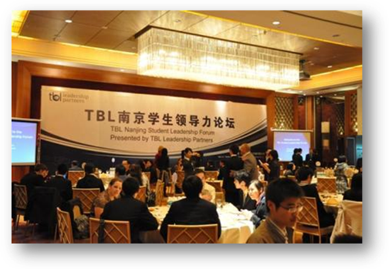

What is the Student Leadership Forum?
Starting at 1pm we will arrange 6 workshops of which students can choose 2 of to attend. The first workshop will be from 1 to 3 and the second will be from 3 to 5. The workshops will be given by American professionals on leadership topics such as how to interview successfully, team building, and emotional intelligence.
After the workshops students will have an opportunity to attend a dinner where 2 keynote speakers will speak on their journey’s in leadership. Our theme for this Forum is:
Journey’s in TBL Leadership – Real Stories from Real Leaders.

TBL Forum Purpose:
In accordance with the TBL cause, the purpose of the TBL forum is to leverage the skills and experiences of successful entrepreneurs to influence and grow the next generation of business leaders around the world.

Developing and Influencing the next Generation of Leaders:
By invitation only, the top 120 students, faculty and local business professionals in the Nanjing area will be invited to participate in the Nanjing Leadership Forum each semester.
4 Benefits of attending the Forum:
1. Exposure to Global Business Leaders
Hear Successful Entrepreneurs and Global Business Leaders speak on Leadership Principles:
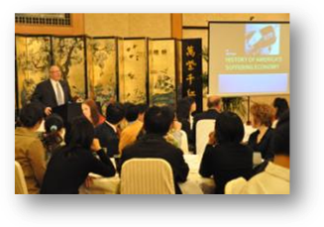
Our keynote speakers are:

Kurt Gusinde is a Senior Vice-President and Senior Investment Manager at Exeter Financial. Kurt has over twenty years of professional investment management experience and specializes in providing comprehensive, customized investment management solutions for individuals, trust, foundation, and endowment clients.

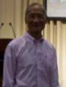
Johnson Lam is a retired senior executive with over 35 years of experience in top Fortune 100 global financial institutions. Prior to his retirement in 2006, Jonson served as Senior Vice President at American Express Company for ten years in the area of information technology. He also has fifteen years of experience as Managing Director at Bankers Trust, a premier investment bank in Wall Street, and held a variety of senior manager positions in a number of other top financial institutions including JP Morgan and Chase Manhattan Bank.

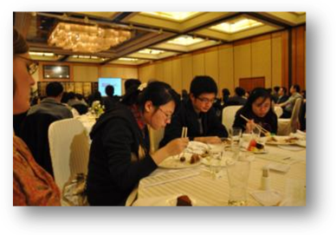
2. Students are treated to a nice meal and have an opportunity to engage with other Leadership Students about Forum topics.
During the meal the students have a chance to discuss the Forum topics at their table which will be hosted by an American professional

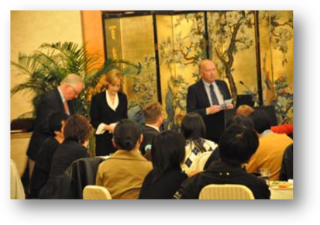
3. Students have an opportunity to ask Successful Business Leaders their questions.
During the Forum students can submit their questions about the topic to the speakers and hosts to be addressed.

4. Students will have an opportunity to continue to discuss Forum Topics with other students around the city as well as apply what they learn with a group of like-minded peers.
The Forum is designed to be a catalyst to encourage students to begin thinking about developing as a leader in order to have a successful business career, impact their community as well as positively influence their colleagues and employees they work with. In order to help students continue to develop their skills as a leader TBL has developed questions and curriculum students can continue to meet and discuss about on their campuses after the Forum.
What’s the CATCH?
Why does TBL sponsor this event and how do they benefit?
TBL Business Development is made up of these businesses:
TWH Collectibles, TBL Leadership Partners, PT USA, and Manitowoc Mainstreet
Our purpose is to partner with and help business leaders deliver Triple Bottom Line excellence in their places of business by achieving:
1. Deliver world class business results
2. Generate economic development and community goodness where we do business
3. Grow and develop people professionally and personally

The opportunity to develop Influential students is the Catch:
TBL Businesses have been greatly blessed by China and the Chinese people. This Leadership Forum is one way they have chosen to “give back” to China and to invest in, influence and grow China’s future leaders as the next “Global Leaders” that will impact the world.
The Forum Participants
TBL is seeking to invite students who fit the following criteria in the following categories:
1. Students who demonstrate Academic Excellence.
This means students who take their studies seriously, make good grades and are respected by their teachers and their peers for their academic hard work.
2. Students who are involved in extra-curricular activities.
TBL is looking for students who are demonstrating leadership ability on their campuses by being involved in or leading extra-curricular activities.
3. Students who are having a positive impact in their community, on their campus and in Nanjing .
TBL is looking for students who have a desire to positively impact their community through serving as a leader. This includes service organizations that help the environment, the campus, or people. Includes things like: Beautifying the environment by picking up trash or cleaning something up. Planting trees. Serving other students or people by giving money, teaching disadvantaged children, feeding the poor or caring for the needs of disadvantaged people.

4. Students who desire to have a positive future impact in their business, in their city and in their world after they graduate.
We have found that many students have a purpose or goals that only benefits themselves. TBL is looking for students who want to live beyond themselves to impact others.

Other characteristics TBL is looking for:
a. Students who model the way for other students. They are respected for setting the example for other students with their life, values and intentionality.
b. Students who cooperate and communicate well with other students to foster and inspire a Shared Vision. They are able to cast vision for their ideas as well as enlist others to help.
c. Students who challenge the process. They search for opportunities to solve problems. They experiment and are willing to take risks.
d. Students who enable others to act. They foster collaboration and strengthen others.
e. Students who encourage the living from the heart and develop relationships.
f. Students who exhibit excellence in Moral Leadership to call others to a Higher Purpose.
g. Students who exhibit humility in their daily life and studies.

APPLY NOW!

You can download the application form at
http://tblleaders.com/blog/

AND

send it to:
2010SpringForum@gmail.com
by March 21st.

